4.3 Image Compression
close all;
clear all;
clc;
% (a)
N=8;
for m=1:N
for n=1:N
e=zeros(N,N);
e(m,n)=1;
b = idct2(e);
subplot(8,8,m+(n-1)*N)
imagesc(b)
colormap(gray)
set(gca,'Xtick',[])
set(gca,'Ytick',[])
axis('square')
end
end
% Explanation: 1) The code above has a matrix called e which contains the DCT coefficients. Then it uses idct2, the invert DCT that converts the coefficients to the subimage. 2) As we see, the lower right cosine waves have the higher frequency than the ones from upper
% left. 3) Yes it does. Essentially, the matrix e only contains o and 1. So
% any 8 image of pixels could be the linear combination of these basis
% waveforms, as long as we provide different amplitude/weighted constants.

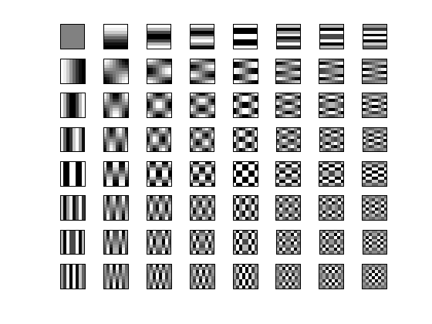

(b)
load cameraman.mat;
figure;
[M,N] = size(x);
Mblocks = M/8;
Nblocks = N/8;
% compute DCT of 8x8 subimages
for m = 1:Mblocks
for n=1:Nblocks
Mrange = (m-1)*8+1:(m-1)*8+8;
Nrange = (n-1)*8+1:(n-1)*8+8;
block = x(Mrange,Nrange);
DCTblock = dct2(block);
y(Mrange,Nrange) = DCTblock;
end
end
imagesc(abs(y));
colormap(gray);
title('DCT coefficient');
% Explanantion: The code first divide the image into 8*8 subimages, and
% then compute the DCT of the subimages. When we display the resulting
% image y, we see a matrix of dots. Magnify these dots we can we blocks
% with colors of white, black, or in between. They are all linear
% combination of the cosine waves. And that makes sense when we look at the
% middle part of y, where the cameraman's body becomes relatively dark.
% The reason is that when we look at original cameraman's body, its color
% is black, meaning the color component is a constant of zero. This
% correspond to the constant DCT signal.

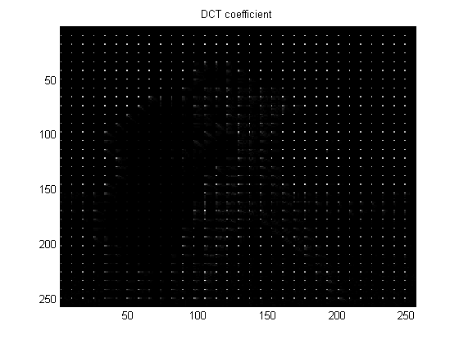

(c)
Q = [16 11 10 16 24 40 51 61;
12 12 14 19 26 58 60 55;
14 13 16 24 40 57 69 56;
14 17 22 29 51 87 80 62;
18 22 37 56 68 109 103 77;
24 35 55 64 81 104 113 92;
49 64 78 87 103 121 120 101;
72 92 95 98 112 100 103 99];
figure;
[M,N] = size(x);
Mblocks = M/8;
Nblocks = N/8;
num = 0;
% compute DCT of 8x8 subimages
for m = 1:Mblocks
for n=1:Nblocks
Mrange = (m-1)*8+1:(m-1)*8+8;
Nrange = (n-1)*8+1:(n-1)*8+8;
block = x(Mrange,Nrange);
DCTblock = dct2(block);
quantized_DCTblock = round(DCTblock./Q);
yquantized(Mrange,Nrange) = quantized_DCTblock;
end
end
imagesc(abs(yquantized));
colormap(gray);
title('quantized DCT');
for a = 1:M
for b = 1:N
if yquantized(a,b)~= 0
num = num + 1;
end
end
end
compressionRatio = num/(M*N)
% After comparing two images, we can see that two images are nearly
% identical. However, we can see that for the elements around the contour of
% the human body, some components in 8*8 subimages are missing.

compressionRatio =
0.1478
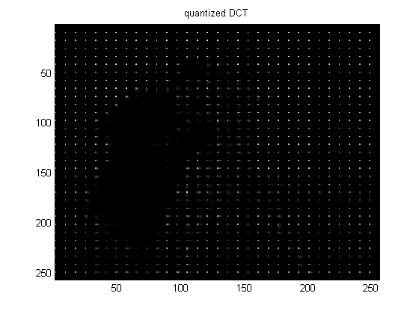

(d)
scalar = 0.5;
Qnew = Q*scalar;
for m = 1:Mblocks
for n=1:Nblocks
Mrange = (m-1)*8+1:(m-1)*8+8;
Nrange = (n-1)*8+1:(n-1)*8+8;
block = x(Mrange,Nrange);
DCTblock = dct2(block);
quantized_DCTblock = round(DCTblock./Qnew);
yquantized(Mrange,Nrange) = quantized_DCTblock;
end
end
num = 0;
for a = 1:M
for b = 1:N
if yquantized(a,b)~= 0
num = num + 1;
end
end
end
compressionRatio2 = num/(M*N)
for m = 1:Mblocks
for n=1:Nblocks
Mrange = (m-1)*8+1:(m-1)*8+8;
Nrange = (n-1)*8+1:(n-1)*8+8;
newDCTblock = round(yquantized(Mrange,Nrange).*Qnew);
newblock = idct2(newDCTblock);
newx(Mrange,Nrange) = newblock;
end
end
figure;
imagesc(newx);
colormap(gray);
title('restored image when scalar factor = 0.5')
scalar = 3;
Qnew = Q*scalar;
for m = 1:Mblocks
for n=1:Nblocks
Mrange = (m-1)*8+1:(m-1)*8+8;
Nrange = (n-1)*8+1:(n-1)*8+8;
block = x(Mrange,Nrange);
DCTblock = dct2(block);
quantized_DCTblock = round(DCTblock./Qnew);
yquantized(Mrange,Nrange) = quantized_DCTblock;
end
end
num = 0;
for a = 1:M
for b = 1:N
if yquantized(a,b)~= 0
num = num + 1;
end
end
end
compressionRatio3 = num/(M*N)
for m = 1:Mblocks
for n=1:Nblocks
Mrange = (m-1)*8+1:(m-1)*8+8;
Nrange = (n-1)*8+1:(n-1)*8+8;
newDCTblock = round(yquantized(Mrange,Nrange).*Qnew);
newblock = idct2(newDCTblock);
newx(Mrange,Nrange) = newblock;
end
end
figure;
imagesc(newx);
colormap(gray);
title('restored image when scalar factor = 3');
scalar = 6;
Qnew = Q*scalar;
for m = 1:Mblocks
for n=1:Nblocks
Mrange = (m-1)*8+1:(m-1)*8+8;
Nrange = (n-1)*8+1:(n-1)*8+8;
block = x(Mrange,Nrange);
DCTblock = dct2(block);
quantized_DCTblock = round(DCTblock./Qnew);
yquantized(Mrange,Nrange) = quantized_DCTblock;
end
end
num = 0;
for a = 1:M
for b = 1:N
if yquantized(a,b)~= 0
num = num + 1;
end
end
end
compressionRatio3 = num/(M*N)
for m = 1:Mblocks
for n=1:Nblocks
Mrange = (m-1)*8+1:(m-1)*8+8;
Nrange = (n-1)*8+1:(n-1)*8+8;
newDCTblock = round(yquantized(Mrange,Nrange).*Qnew);
newblock = idct2(newDCTblock);
newx(Mrange,Nrange) = newblock;
end
end
figure;
imagesc(newx);
colormap(gray);
title('restored image when scalar factor = 6');
% Explanation: As we see, if we multiply a constant less than 1, the
% restored image's quality gets better than the one with a constant bigger
% than 1. The reason is that when we quantize a image, we use
% round(DCTblock./Q). So bigger the Q is, the more components are zeroed
% out, then the quality gets worse. Theremore, when constant is bigger than
% 1, the quality gets worse. When constant is smaller than 1, the quality
% gets better.

compressionRatio2 =
0.2215
compressionRatio3 =
0.0724
compressionRatio3 =
0.0456
